**LAB ASSIGNMENT-6.4**

**Name: Sanjana Karnakanti**

**Roll.no:2403A51327**

Task Description #1:  
• Start a Python class named Student with attributes name, roll_number, and marks. Prompt  
GitHub Copilot to complete methods for displaying details and checking if marks are above  
average.  
Expected Outcome #1:  
• Completed class with Copilot-generated methods like display_details() and is_passed(),  
demonstrating use of if-else conditions.

**Prompt:**

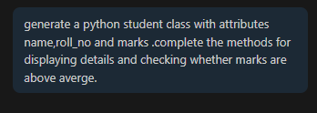

**Code:**

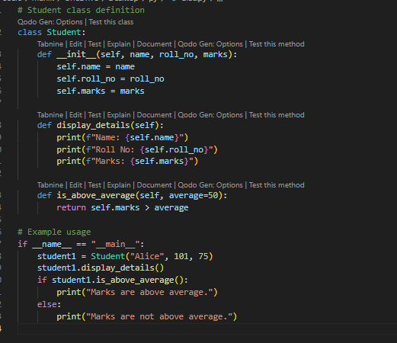

**Output:**

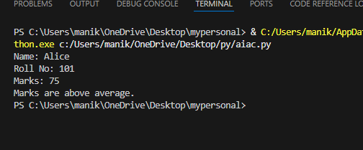

**Observation:** according to the prompt github copilot generated a code with out example usage , in this AI tool github copilot we need to mention to give an example in the prompt.

Task Description #2:  
• Write the first two lines of a for loop to iterate through a list of numbers. Use a comment  
prompt to let Copilot suggest how to calculate and print the square of even numbers only.  
Expected Outcome #2:  
• A complete loop generated by Copilot with conditional logic (if number % 2 == 0) and  
appropriate output.

**Prompt:**

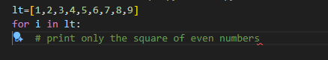

**Code:**

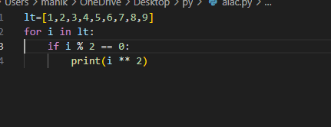

**Output:**

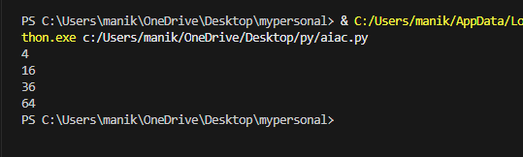

**Observation:** From the given prompt (two lines of for loop code) github copilot generates the complete code and the output is according to the expected outcome.

Task Description #3:  
• Create a class called BankAccount with attributes account_holder and balance. Use Copilot to  
complete methods for deposit(), withdraw(), and check for insufficient balance.  
Expected Outcome #3:  
• Functional class with complete method definitions using if conditions and self attributes. Code  
should prevent overdrawing

**Prompt:**

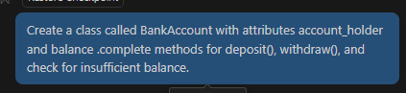

**Code:** 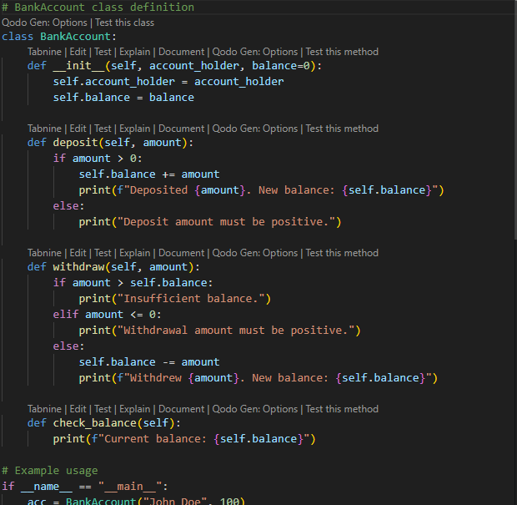

**Output:**

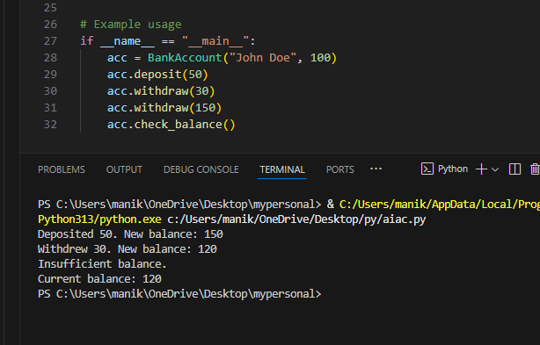

**Observation:** github copilot generated the code according to the prompt. Also used an example for better explanation and output is as expected outcome.

Task Description #4:  
• Define a list of student dictionaries with keys name and score. Ask Copilot to write a while  
loop to print the names of students who scored more than 75.  
Expected Outcome #4:  
• A complete while loop generated by Copilot with proper condition checks and formatted  
output.

**Prompt:**

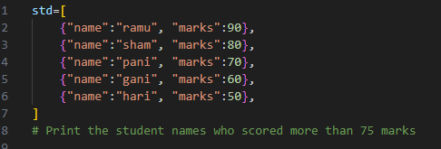

**Code:**

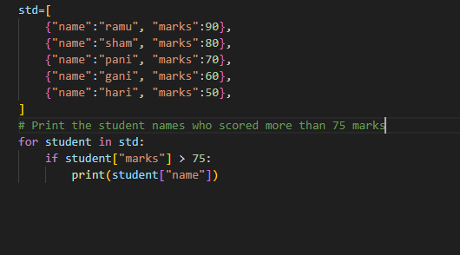

**Output:**

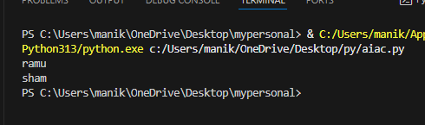

**Observation:** github copilot completed the code that is in the prompt and the output is as expected outcome.

Task Description #5:  
• Begin writing a class ShoppingCart with an empty items list. Prompt Copilot to generate  
methods to add_item, remove_item, and use a loop to calculate the total bill using conditional  
discounts.  
Expected Outcome #5:  
• A fully implemented ShoppingCart class with Copilot-generated loops and if-else statements  
handling item management and discount logic

**Prompt:**

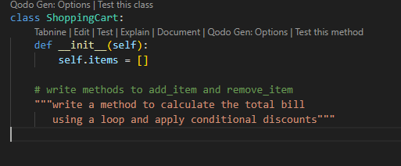

**Code:**

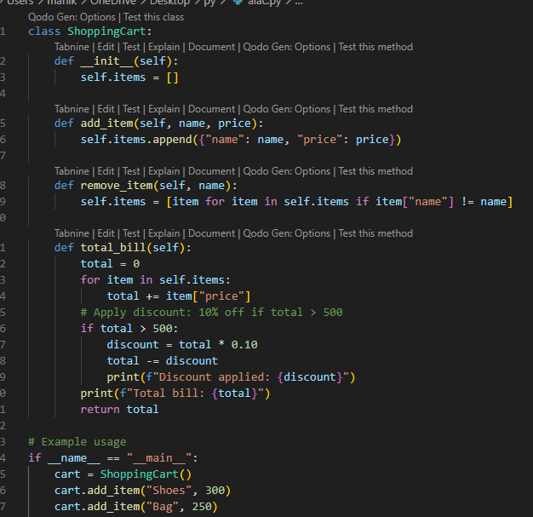

**Output:**

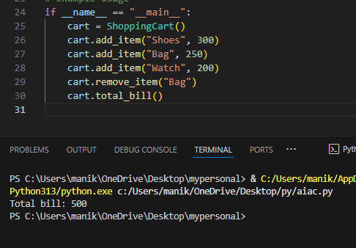

**Observation:** github copilot generated the complete code according to the expected outcome.